Name: Ritika Mohan
Prn: 23070521183
Semester: 5th C (C1)
Aim: Arrays & Objects with Higher-Order Functions:
Use arrays and methods such as push, pop, map(), filter(), reduce(), forEach(). Handle object arrays (e.g., product list). Create a cart total calculator that applies discounts based on criteria.
Output:
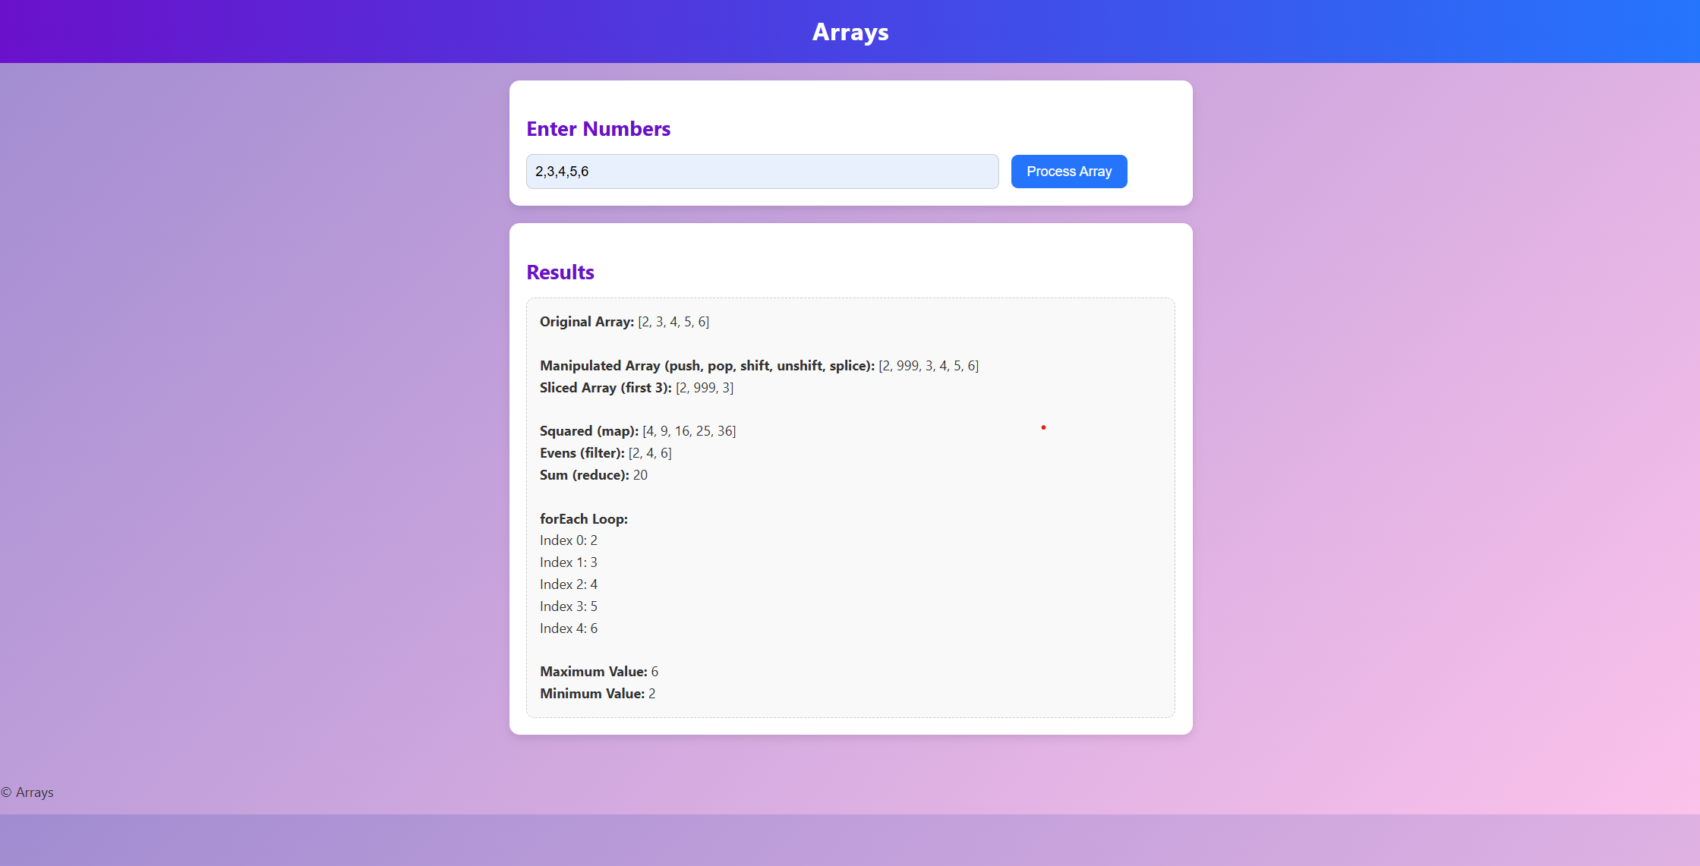
Theory:
- An array is a special variable used to store multiple values in a single name.
- EX: let numbers = [10, 20, 30];
Array Manipulation Methods
- push() → Add at end
- pop() → Remove from end
- shift() → Remove from start
- unshift() → Add at start
- splice() → Add/remove elements at specific position
- slice() → Copy part of an array
Array Higher-Order Methods
- map() → Creates new array by applying a function to each element
- filter() → Creates new array with elements that pass a condition
- reduce() → Reduces array to a single value (like sum, max, min)
- forEach() → Iterates through array elements

Conclusion: Used arrays and methods such as push, pop, map(), filter(), reduce(), forEach(). Handle object arrays .

